**Biological and Physiological  
Adaptations of Birds**

**Objectives**  
 Understand birds’ place in the animal kingdom  
 Where did birds come from?  
 Understand adaptations that make flight possible  
 Skeleton  
 Musculature  
 Respiratory System  
 Circulatory System  
 Digestive System  
 Reproduction  
 Senses  
 Feathers

Fossil Record

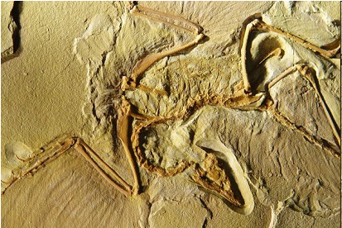

**Archaeopteryx**

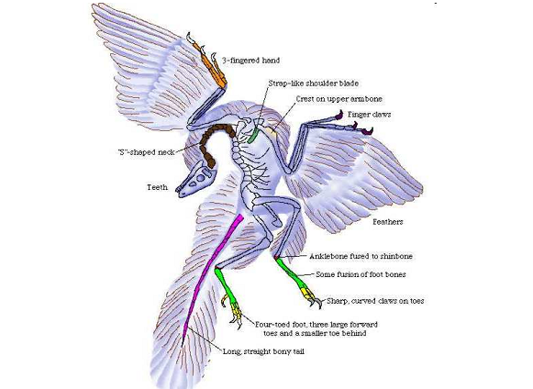

**Skeletal Adaptations**

* The sternum (breastbone), bears a prominent keel where the flight muscles attach
* The furcula (wishbone), serves as a brace during the flight stroke
* Secondary feathers of the wing are supported by the forearm
* Wrist and hand bones are fused to provide
* firm support for the primary feathers

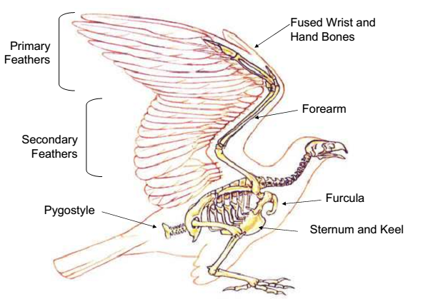

* Solid bones replaced with hollow bones
* Thin internal struts for extra strength where necessary
* Bones of the skull are extremely thin
* Teeth replaced by a horny bill

***Light but Powerful Musculature***

* Most birds have approximately 175 different muscles, mainly controlling the wings, skin, and legs
* The largest muscles control the wings and run between the upper arm and the keel
* The pectoralis major provides the powerful downstroke the supracoracoideus muscle raises the wing
* Uses a pulley-like system to lift the wing
* These muscles constitute about 20 – 25 percent of the bird's total body mass

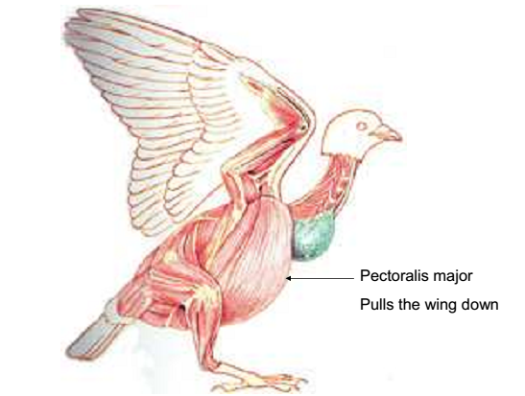

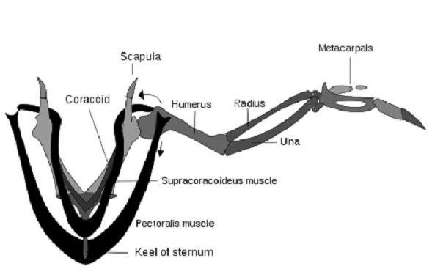

***Respiratory System***

* Due to the high metabolic rate required for flight birds have a high oxygen demand
* Birds ventilate their lungs by means of air sacs these structures are unique to birds, and perhaps dinosaurs, too
* Birds’ lungs obtain fresh air during both exhalation and inhalation
* Birds lack a diaphragm
* The entire body cavity acts as a bellows to move air through the lungs
* The active phase of respiration in birds is exhalation, requiring muscular contraction